Number of awards/medals for outstanding performance in Sports/Cultural activities at University/State/National/International level
Year | Name of the award/medal | Universities/States/National/ International level | Photo
2020-21 | “Sadbhawna” Inter college online competition at Apollo College, Durg | Inter college  (Rangoli ) | 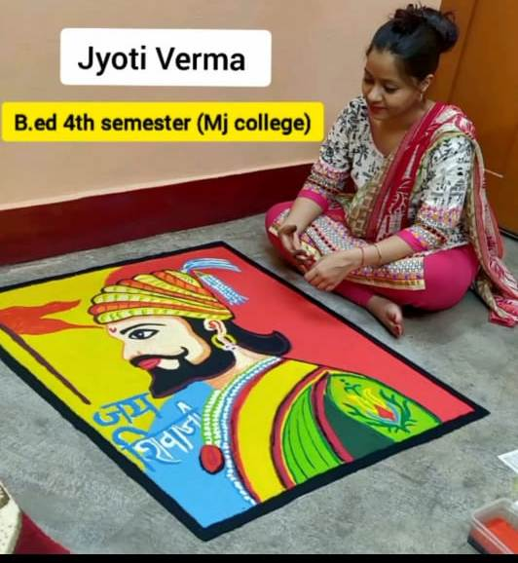
2020-21 | “Sadbhawna” Inter college online competition at Apollo College, Durg | Inter college  (Group Dance) | 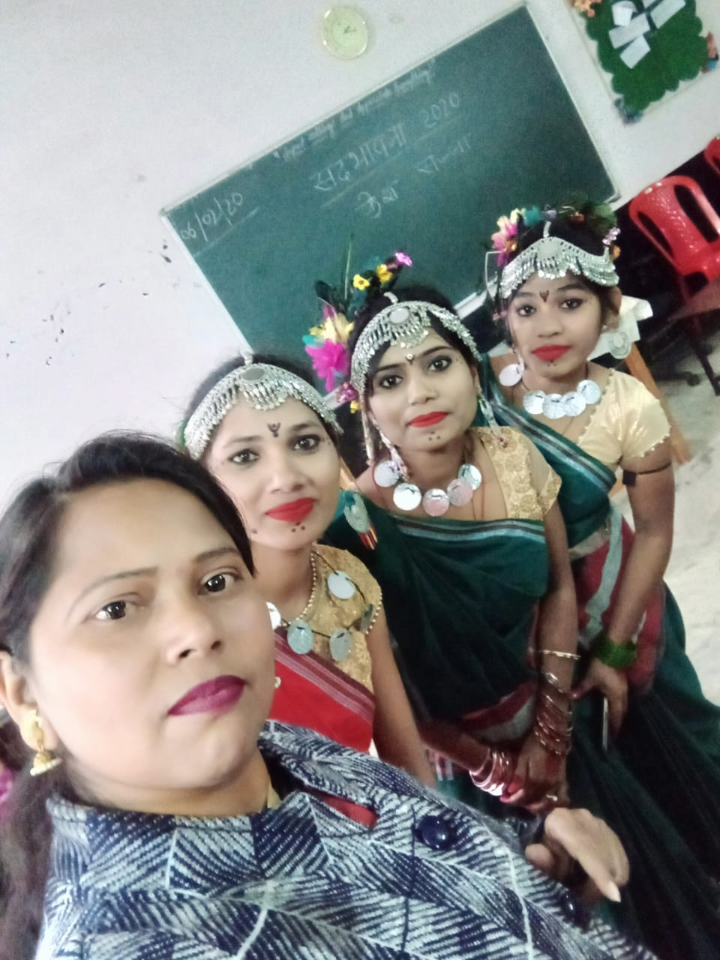
2020-21 | “Sadbhawna” Inter college online competition at Apollo College, Durg | Inter college  (Solo Dance) | 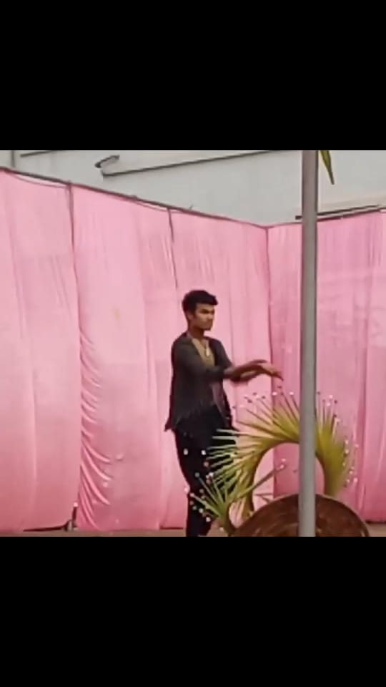
2019-20 | “Masti Ki Pathshala” Organised at S.S. Khanna Girls Degree College, Prayagraj | National (Lok Geet) | 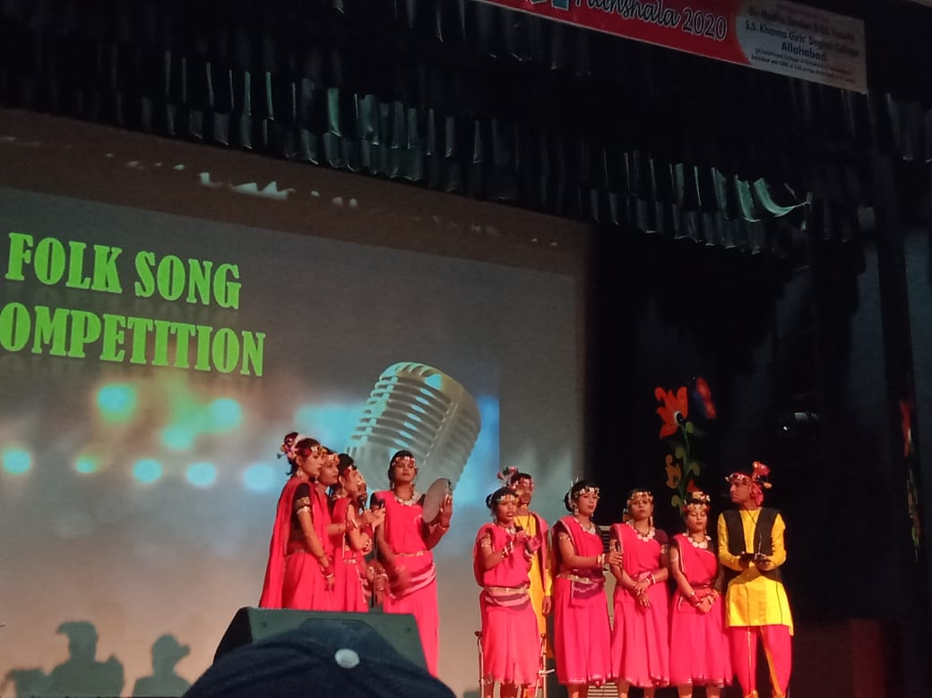
2019-20 | “Masti Ki Pathshala” Organised at S.S. Khanna Girls Degree College, Prayagraj | National (Lok Nritya) | 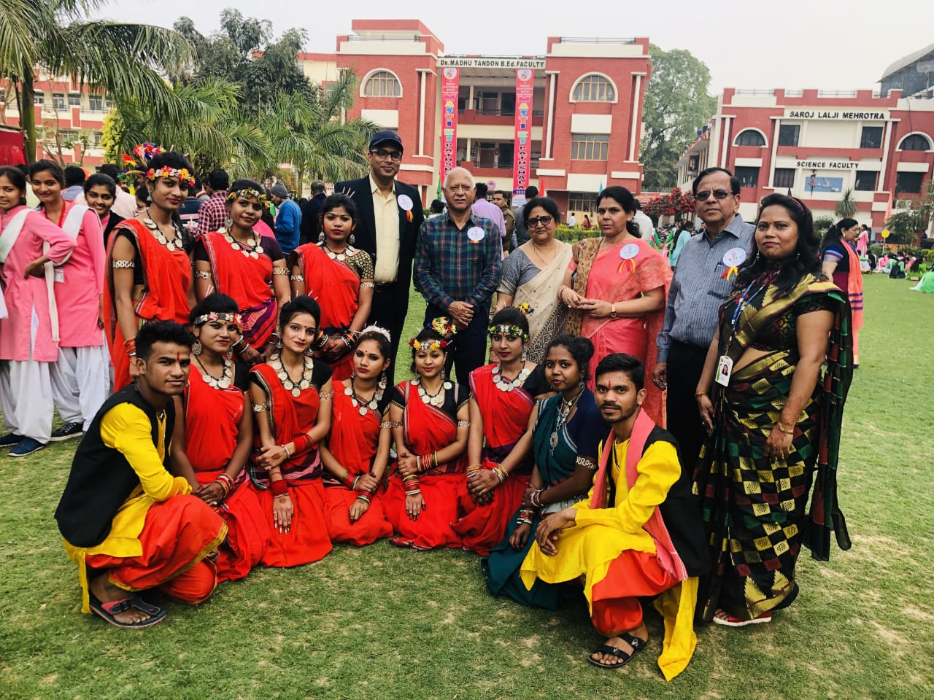
2019-20 | “Masti Ki Pathshala” Organised at S.S. Khanna Girls Degree College, Prayagraj | National (Face Painting) | 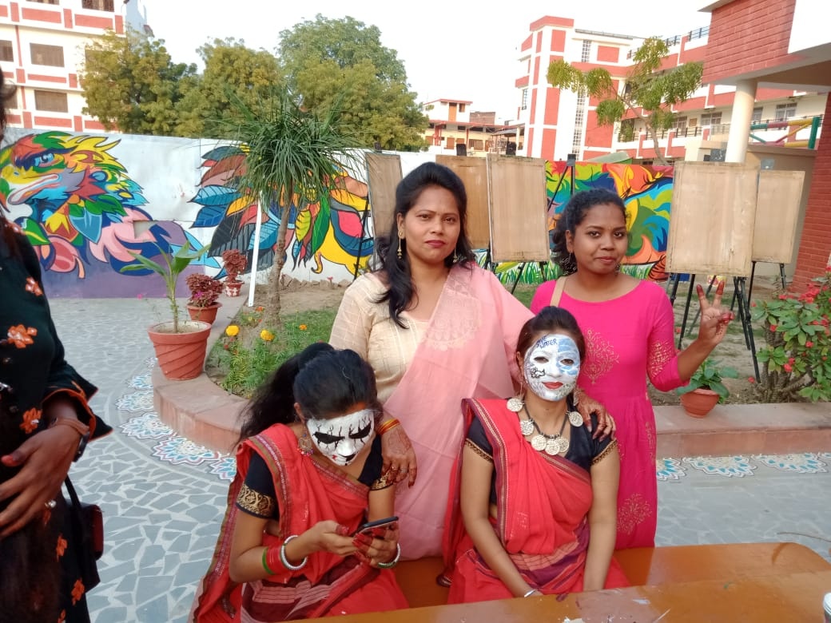
2018-19 | All India Essay Writing Event | National (Essay ) | 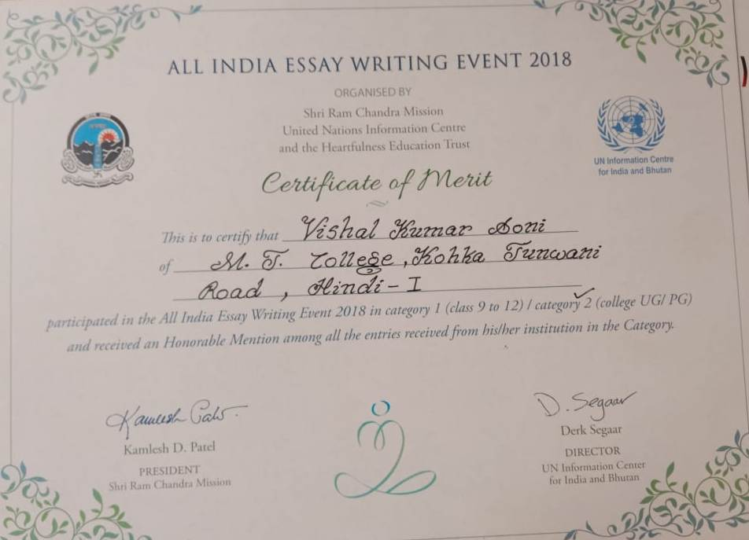
2017-18 | Govt. VYT PG Autonomous Mahavidyalaya | Inter College  (Essay) | 